**Citrix VDA Registration Alerting**

**This article has been updated to reference Goliath Agent version 12.0 and newer.**

Goliath Performance Monitor has the ability to alert on unregistered Citrix Virtual Desktops (VDI) out of the box (see screenshot below). However, many would like to alert on unregistered XenApp Servers. To do so, we can leverage our custom monitoring to execute a query on a scheduled basis to a check a registry key which includes if the VDA is registered or unregistered. See full details outlined below.

**How to monitor and alert for unregistered Citrix VDI:**

1. Navigate to the **Configure - Monitoring Rules** page
2. Select and edit the rule named **Citrix XenDesktop - VDI Session & VDI Availability**
3. Enable the checkbox option for **Unregistered VDI**

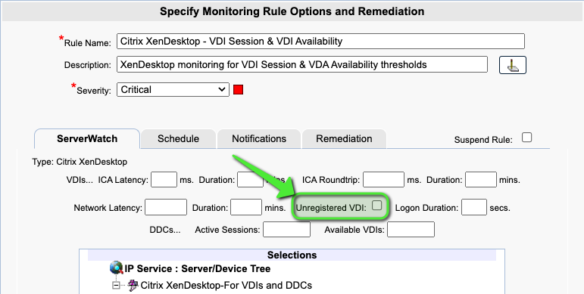

**How to monitor and alert for unregistered Citrix XenApp Servers:**

1. Navigate to the **Configure - Monitoring Rules** page
2. Click the **New** button
3. Chose the option for **Advanced Watch**
4. Configure the **Program Name** field to be the following:
   1. C:\Windows\System32\WindowsPowerShell\v1.0\powershell.exe
5. Configure the **Cmd-line Options** field to be the following
   1. $reg = ((GP -Path 'HKLM:\SOFTWARE\Citrix\VirtualDesktopAgent\State' -Name Registered).Registered); exit $reg
6. Configure the "exit code" to be "=2", if something other then 2 is returned it will trigger an alert

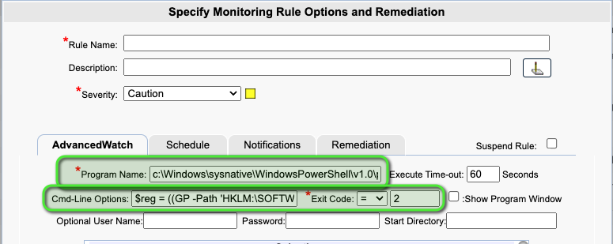

**see article** [**Configure Advanced Watch Rules**](https://support.goliathtechnologies.com/hc/en-us/articles/360024347953) **for full configuration details**